Michael S. McGlade (he, him, él)

Hello students, I am glad that you are taking the course. A little bit about me.

I was a raspberry farmer the first ten years of my adult life, and after that I did my MA and PhD at Arizona State University, where I specialized in Latin America, cultural ecology, climate impacts and water resources. While working in Mexico in 1990, I met my wife-to-be in the splendid colonial city of Guanajuato seen in the photo below, and a year later we got married.



She teaches Spanish locally and we have two adult children. Some of my best (and heartfelt) scholarship – relevant to this class - came out of a seven year period working on Latinx community-based research on health care access and related topics, which culminated in the article [The Latina Paradox: An Opportunity for Restructuring Prenatal Care Delivery](https://www.ncbi.nlm.nih.gov/pmc/articles/PMC1448590/). The social justice theme in this article reflects a longstanding interest in the topic.

I chose WOU as a place to work in 1994, due to its teaching emphasis and proximity to the Oregon Coast and Cascades. I am an avid mountain biker, kite surfer, and day hiker.

There are few things as enjoyable as spending time in the forests of Oregon, whether it be in the Coast Hills or Western Cascades, or the pine forests on the east of Cascades. A recent photo of me kitesurfing at the Oregon Coast:

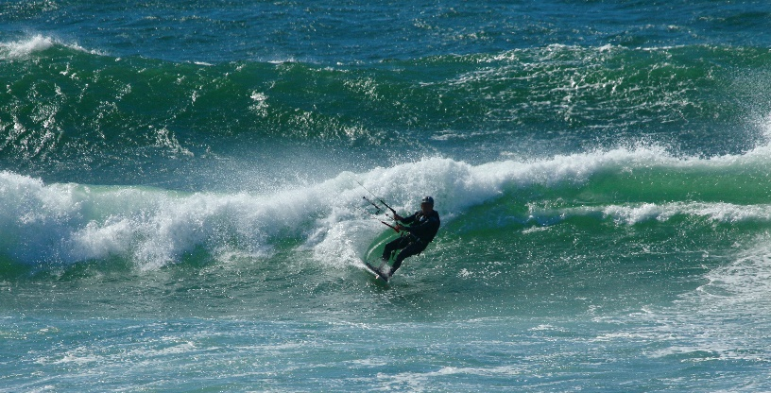

And the classic pines near Sisters Oregon, where I love riding Forest Service roads:

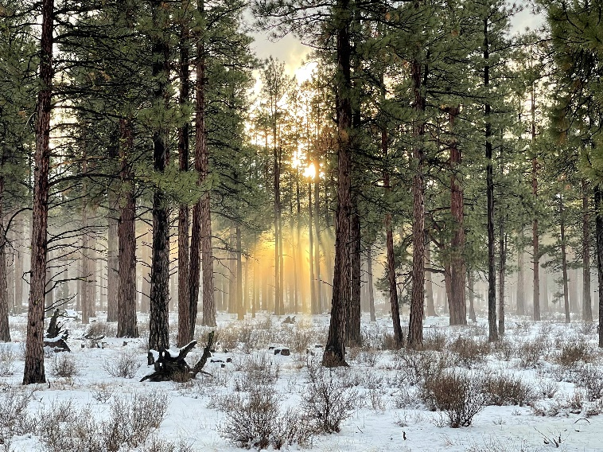

I look forward to learning a bit about each of you. About half of the enrollment is students who have previously taken one or more classes from me, so thanks for your continuing interest!